Convergence Algorithm:

We were taking $θ$ randomly previously which is not efficient. Instead we will be using convergence algorithm that will help initialize $θ_{1}$ value and then based on the gradient descent, it will be able to increase or decrease the $θ_{1}$ value.

Convergence Algorithm:

Aim: To optimize the changes of $θ_{1}$ values which is the slope.

Principle - Repeat until convergence, i.e, meets the global minima point.

Equation:

$θ_{j}:= θ_{j}- α\frac{∂}{∂θ_{j}} J(θ_{j})$

:= means it is an iterative process

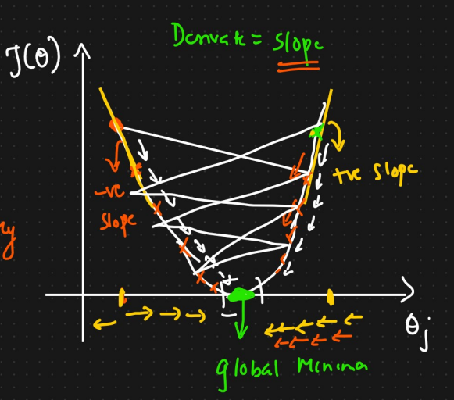

$\frac{∂}{∂θ_{j}} J\left(θ_{j}\right)$ is nothing but the slope.

Slope = y2 – y1 / x2 – x1

Since y value is decreasing on the left hand side, the slope will be negative. This will add some value to the $θ_{j}$.

Since y value is increasing on the right hand side, the slope will be positive. This will subtract some value from the $θ_{j}$.

This is an iterative process.

After repeating this process, after some time, $θ_{j}$ will converge to the global minima.

α is the Learning rate.

It is usually initialized with a smaller variable for example 0.001

Learning rate controls the speed at which convergence happens.

If it is a very small value, it will take more time to converge.

If it is a very big value, it may never converge.

Should be a optimum value.

Conclusion:

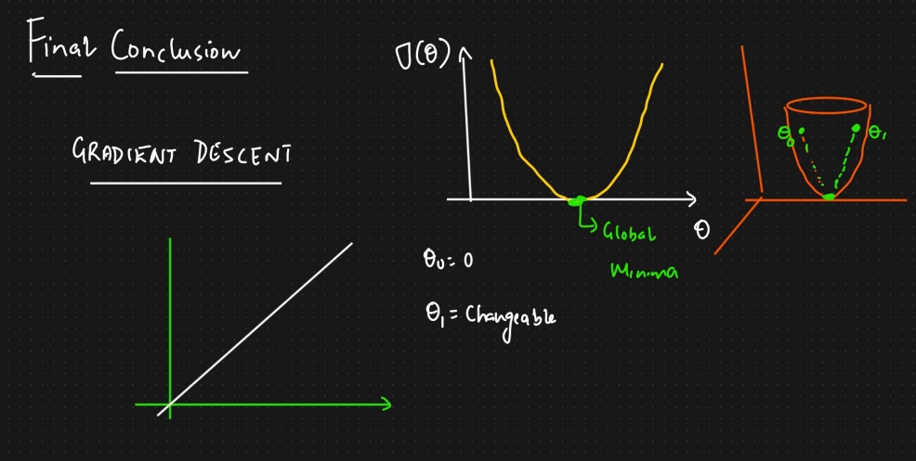

We took $θ_{0}$ as 0 so that we could represent the diagram in 2d.

If $θ_{0}$ is not 0, we will have the diagram shown and both $θ_{0}$ and $θ_{1}$ are there and our aim is to converge towards global minima.

Convergence algorithm:

Repeat until convergence.

Updated equation:

$θ_{j}:= θ_{j}- α\frac{∂}{∂θ_{j}} J(θ_{0}, θ_{1})$

Where $J\left(θ_{0},θ_{1}\right)=\frac{1}{2m} \sum_{i=1}^{m}{{(h_{θ}{\left(x\right)}^{(i)}- y^{(i)})}^{2}}$

M is the number of data points we have.

So the derivative, $\frac{∂}{∂θ_{j}} J(θ_{0}, θ_{1})$

Becomes $\frac{∂}{∂θ_{j}} \frac{1}{2m} \sum_{i=1}^{m}{{(h_{θ}{\left(x\right)}^{(i)}- y^{(i)})}^{2}}$

We have to find the derivative for j = 0 and j = 1

If j = 0,

$\frac{∂}{∂θ_{0}} \frac{1}{2m} \sum_{i=1}^{m}{{(h_{θ}{\left(x\right)}^{(i)}- y^{(i)})}^{2}}$

= $\frac{1}{m} \sum_{i=1}^{m}{{(h_{θ}{\left(x\right)}^{(i)}- y^{(i)})}^{1}}$

$h_{θ}\left(x\right)= θ_{0}+ θ_{1}x$

Where $θ_{1}x$ is constant so becomes 0

If j = 1,

$\frac{∂}{∂θ_{1}} \frac{1}{2m} \sum_{i=1}^{m}{{(h_{θ}{\left(x\right)}^{(i)}- y^{(i)})}^{2}}$

= $\frac{1}{m} \sum_{i=1}^{m}{{({(θ}_{0}+ θ_{1}x)- y^{(i)})}^{1}}$

Here $θ_{0}$ becomes constant

= $\frac{1}{m} \sum_{i=1}^{m}{{({(θ}_{0}+ θ_{1}x)- y^{(i)})}^{1}}$ ${(x) }^{i}$

Repeat until convergence {

$θ_{0}:= θ_{0}- α\frac{1}{m} \sum_{i=1}^{m}{{(h_{θ}{\left(x\right)}^{(i)}- y^{(i)})}^{1}}$

$θ_{1}:= θ_{1}- α\frac{1}{m} \sum_{i=1}^{m}{{({(θ}_{0}+ θ_{1}x)- y^{(i)})}^{1}}$ ${(x) }^{i}$

}